**User Manual**

By: Tim & Thomas

project is here: https://github.com/NoFlintGrey/SBF-Final.git

Kedelaron is a top down action game where you must defeat the boss to win. There are a number of levels that you can be placed in.

Controls:

Movement: Mobile: Joystick, Desktop: Arrow Keys

Attack: Mobile: Tap on the right side of the screen, Desktop: Spacebar.

To run as android use androidlauncher.java.

To run in desktop use Desktoplauncher.java

screenshots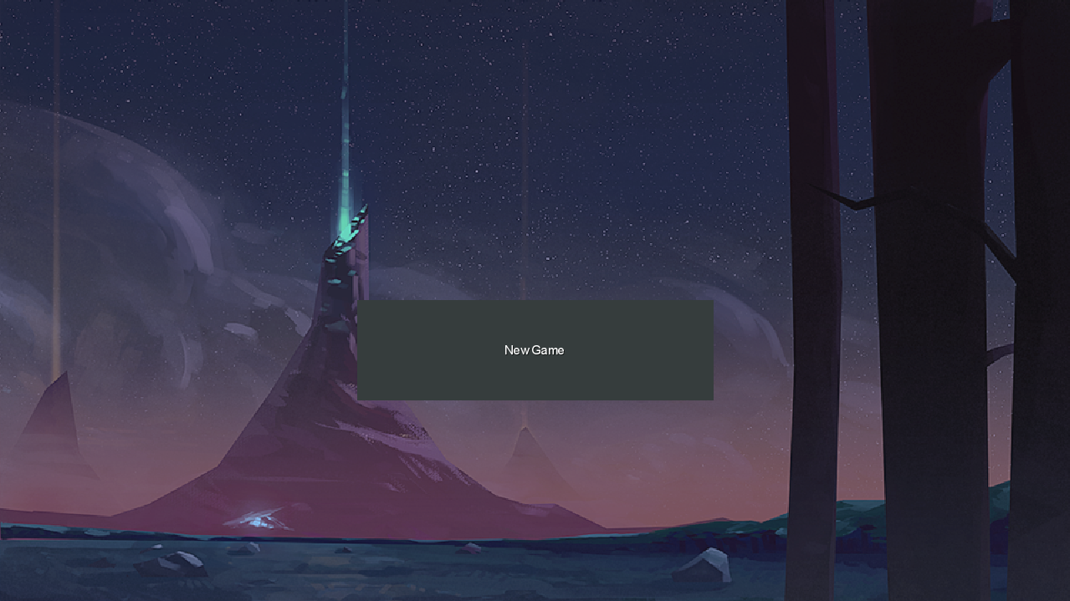Start Screen tapping the new game button will launch the Character select screen.

Character select screen clicking on the arrow keys will cycle through the character's, hit back will take you back to the Start Screen, hitting continue will start the game

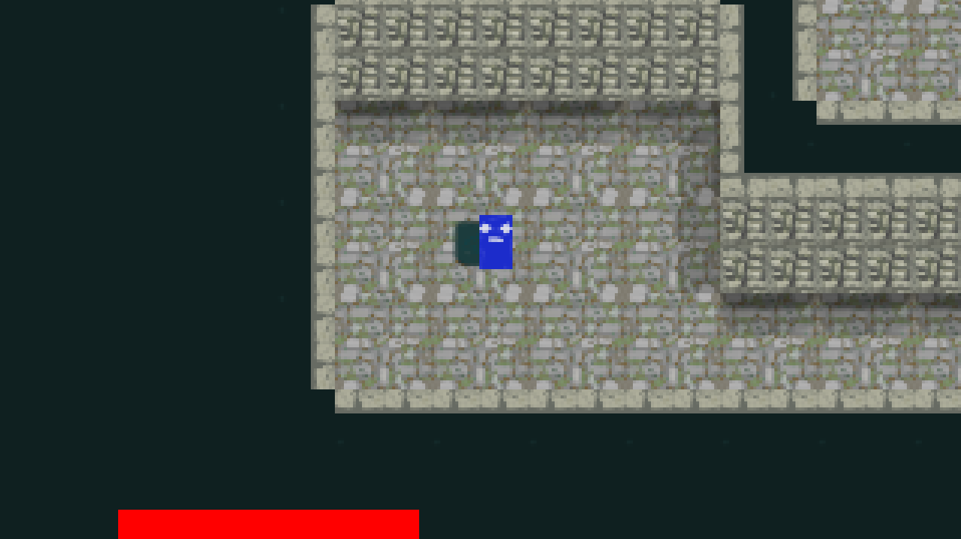Spawn with blue player, when you start the game you will be placed at the player spawn tile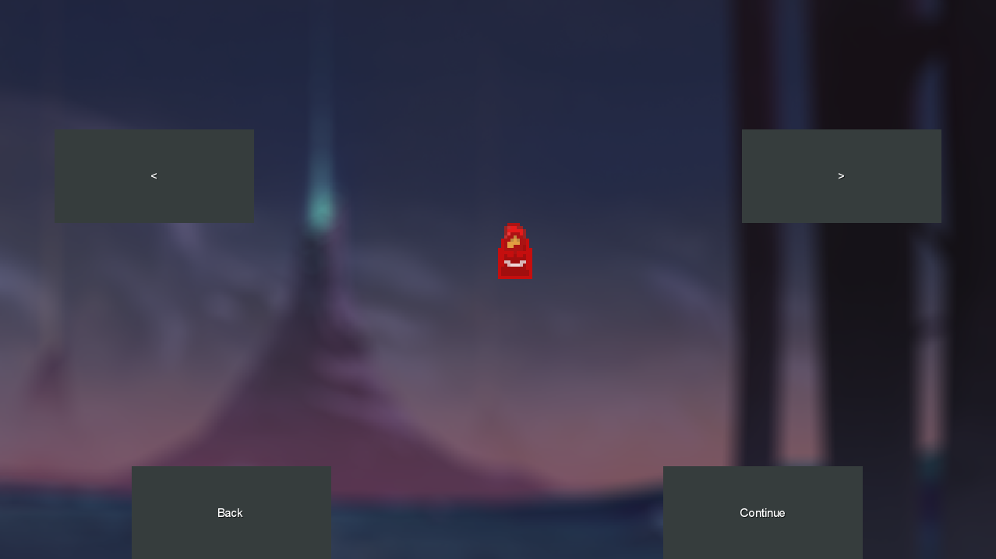

Basic Enemies and key the enemies will follow and attack you, walking over the key will pick it up. 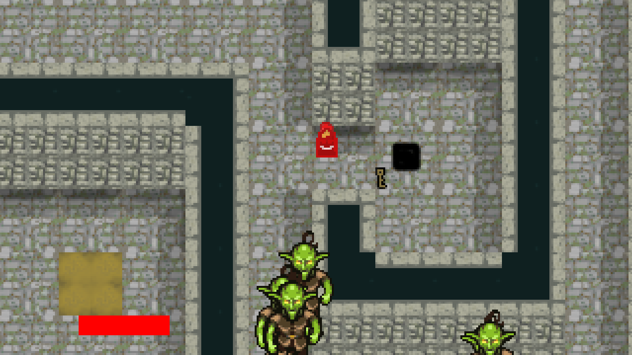

This is a door they are locked and you can not go through them, to unlock them find a key and walk up to the door, it will unlock. Inside could be a number of things mostly likely a teleport.

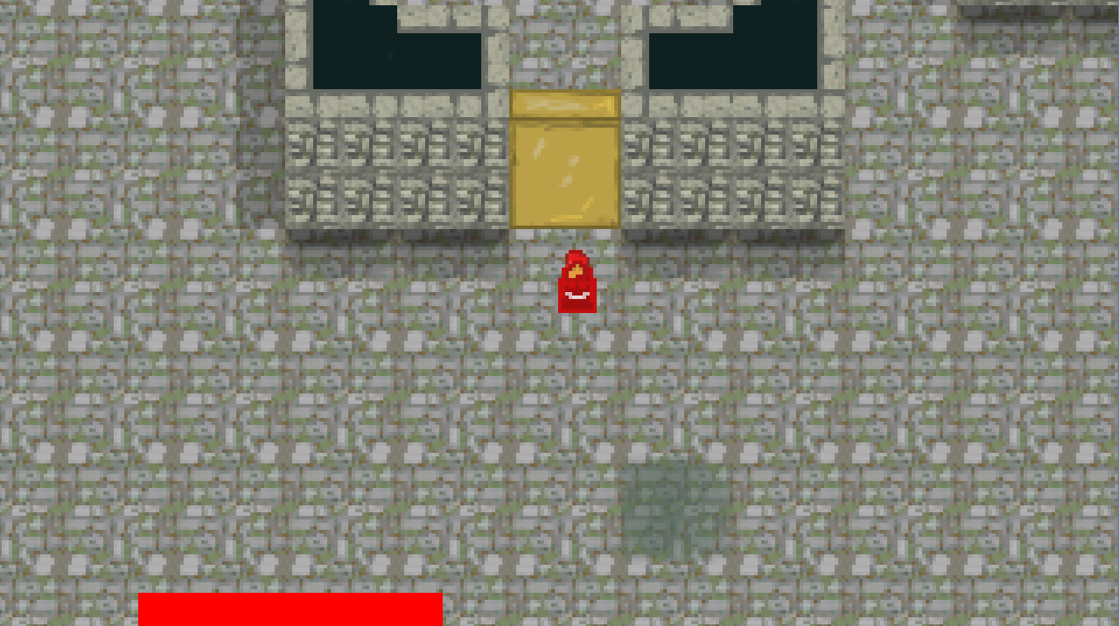

Boss, this is the final enemy, defeat him and win the game.

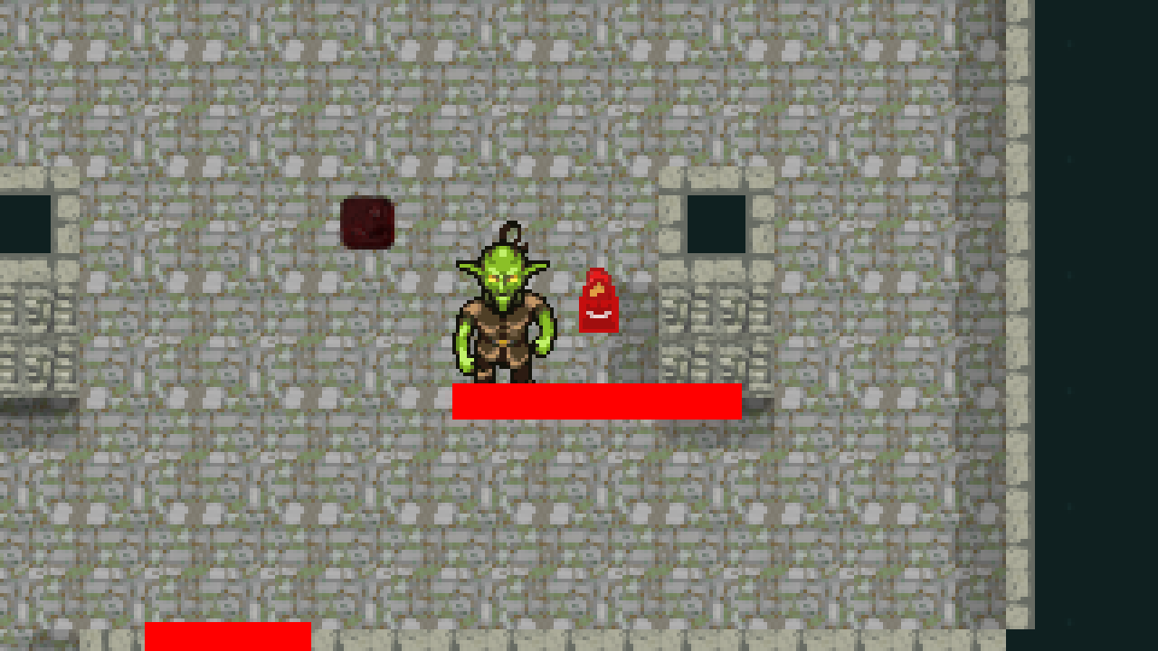 Win screen, appears when you kill the Boss, if you die a nearly identical screen appears, but it says that you died. 